Vectors: Notes

Table of Contents
1. Vector Representation and Magnitude
2. Basic Vector Operations
3. Multiplying Vectors
4. Linear Combinations
5. Span
6. Basis Vectors
7. Linear Independence
8. Position Vectors and the Dual Nature of Vectors
9. Linear Transformations and Matrices
10. Matrix Multiplication (Composing Transformations)
11. The Derivative: Instantaneous Rate of Change
12. Rules of Derivatives
13. Integrals

1. Vector Representation and Magnitude
A vector is usually written as an arrow pointing in a specific direction. On a coordinate grid, it is often written as a column of numbers or inside parentheses.
For example, a two-dimensional vector v⃗ = (3, 4) means you move 3 units to the right along the x-axis and 4 units up along the y-axis.

Magnitude (Length)
To find the length of a vector, you use the Pythagorean theorem (a² + b² = c²).
For a vector v⃗ = (x, y), its magnitude is written as |v⃗| and calculated as:
|v⃗| = √(x² + y²)
For our example vector (3, 4):
|v⃗| = √(3² + 4²) = √(9 + 16) = √25 = 5

2. Basic Vector Operations
Just like regular numbers, you can add, subtract, and multiply vectors.

Vector Addition
To add two vectors together, you simply add their corresponding x and y parts.
(x₁, y₁) + (x₂, y₂) = (x₁ + x₂, y₁ + y₂)
Real-world analogy: Imagine you walk 3 blocks East and 4 blocks North (Vector 1). Then, you walk 1 block East and 2 blocks North (Vector 2). Your total movement is 3 + 1 = 4 blocks East and 4 + 2 = 6 blocks North.

Vector Subtraction
To subtract, you subtract the corresponding x and y parts.
(x₁, y₁) − (x₂, y₂) = (x₁ − x₂, y₁ − y₂)

Scalar Multiplication
A scalar is just a regular number (like 2, −1, or 1/2). Multiplying a vector by a scalar changes its size or flips its direction (if the scalar is negative), but it still points along the same line. To do this, multiply every part inside the vector by the scalar.
c(x, y) = (c·x, c·y)
For example, multiplying (3, 4) by 2 gives:
2(3, 4) = (2·3, 2·4) = (6, 8)

3. Multiplying Vectors
In algebra, there are two special ways to multiply two vectors together:
- The Dot Product: This multiplies two vectors and results in a single regular number (a scalar). It is used to find the angle between two vectors or to check if they are perpendicular (at a 90° angle).
- The Cross Product: This multiplies two vectors and results in a brand new vector that is perpendicular to both of the original vectors. It is highly useful in 3D geometry and engineering.

4. Linear Combinations
A linear combination is the result of scaling vectors and adding them together.
- You multiply each vector by a scalar constant.
- You add those resulting vectors together.
Formula: v⃗ = c₁v⃗₁ + c₂v⃗₂ + ⋯ + cₙv⃗ₙ
Example: Given v⃗₁ = (1, 2) and v⃗₂ = (3, 0), a linear combination using scalars 2 and −1 is:
2(1, 2) − 1(3, 0) = (2, 4) + (−3, 0) = (−1, 4)

5. Span
The span of a set of vectors is the collection of all possible linear combinations you can create with them.
- It represents the entire geometric space you can reach using those vectors.
- In 2D space: Two vectors pointing in different directions span the entire 2D plane.
- Line Span: If two vectors point in the exact same direction, their span is just a single straight line.
- Point Span: The span of a zero vector is just a single point at the origin.

6. Basis Vectors
A basis is a specific set of vectors that acts as a minimal coordinate system for a space.
- Every vector in the space can be written as a unique linear combination of the basis vectors.
- Rule 1: The basis vectors must span the entire space.
- Rule 2: They must be linearly independent (no vector in the set can be made from a linear combination of the others; none are redundant).
Standard Basis: In a standard 2D grid, the basis vectors are î = (1, 0) (one step right) and ĵ = (0, 1) (one step up).

7. Linear Independence
Vectors are linearly independent if no vector in the set can be written as a linear combination of the remaining vectors. Geometrically, this means none of the vectors are redundant, and each one adds a completely new dimension or direction to the space.
If a set of vectors is not independent, it is called linearly dependent.

The Mathematical Definition
A set of vectors {v⃗₁, v⃗₂, …, v⃗ₙ} is linearly independent if the only solution to the vector equation:
c₁v⃗₁ + c₂v⃗₂ + ⋯ + cₙv⃗ₙ = 0⃗
is the trivial solution where all scalars must be zero:
c₁ = c₂ = ⋯ = cₙ = 0
If you can find any combination where even one scalar c is not zero, the vectors are dependent.

Visual Intuition
- 2D Space: Two vectors are independent if they do not lie on the same line. If they are parallel, they are dependent.
- 3D Space: Three vectors are independent if they do not all lie flat on the same 2D plane. If the third vector lies on the plane spanned by the first two, it is dependent.

How to Check for Independence (Step-by-Step)
To test if a set of vectors is independent, you can arrange them into a matrix as columns and evaluate them.

Method 1: The Determinant (For Square Matrices Only)
If you have the same number of vectors as there are dimensions (e.g., three 3D vectors), put them into a matrix and find the determinant.
- Determinant ≠ 0: The vectors are linearly independent.
- Determinant = 0: The vectors are linearly dependent.

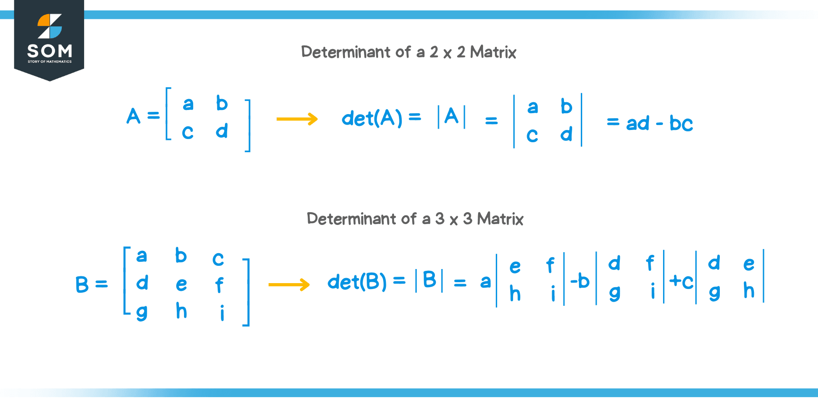

Method 2: Gaussian Elimination (Row Reduction)
For any number of vectors, set up a system of equations matching the definition formula and reduce the matrix to Row Echelon Form (REF).
- If every column has a pivot, there are no free variables. The vectors are linearly independent.
- If there is a column without a pivot, a free variable exists. The vectors are linearly dependent.

Example: Testing Two 2D Vectors
Let's test if v⃗₁ = (1, 2) and v⃗₂ = (3, 4) are independent.
1. Set up the matrix equation
c₁(1, 2) + c₂(3, 4) = (0, 0)
⎡ 1 3 ⎤
⎣ 2 4 ⎦
2. Calculate the determinant
Det = (1·4) − (3·2) = 4 − 6 = −2
3. Evaluate the result
Since the determinant is −2 (which is not 0), the only way to solve the equation is if c₁ = 0 and c₂ = 0.
✅ Conclusion: The vectors (1, 2) and (3, 4) are linearly independent.

8. Position Vectors and the Dual Nature of Vectors
Every vector can be visualized as a point in space if it starts at the origin (0, 0). When you treat a vector this way, it is called a position vector.
In linear algebra, data science, and physics, the choice between looking at a vector as an arrow or a point depends entirely on what you are doing.
Visualizing as an Arrow | Visualizing as a Point
Focuses on movement, force, or velocity. | Focuses on location, data states, or coordinates.
Represents a shift: “Go 3 units right, 4 units up.” | Represents a destination: “The target is at (3, 4).”
Can be drawn anywhere on the graph. | Is tethered strictly to the origin (0, 0).

Geometric Example
Consider the vector v⃗ = (3, 4).
- As an arrow: It is a displacement vector of length 5 pointing up and to the right.
- As a point: It is the coordinate point (3, 4). The vector coordinates tell you exactly how to get to that point from the center of the grid.

Why This Matters in Modern Technology
1. Machine Learning and Data Science
Data scientists represent real-world items as vectors (points) in high-dimensional space. This is called an embedding.
Example: A house might be a vector (3, 2, 250000) representing 3 bedrooms, 2 bathrooms, and a $250,000 price tag. By treating this vector as a point in a 3D graph, algorithms can find “nearby” points to recommend similar houses.
2. Computer Graphics and Physics Engines
Video games use vectors to track player locations. The player's current location is stored as a position vector (point). The player's movement direction and speed are stored as a velocity vector (arrow). To move the player, the game engine adds the arrow vector to the point vector, outputting a brand new point vector for the next frame.

9. Linear Transformations and Matrices
A linear transformation is a function that maps vectors from one space to another while keeping the underlying grid lines straight and parallel. A matrix is a compact spreadsheet of numbers that acts as the mathematical transformation machine.

When you multiply a vector by a matrix, you are transforming that vector.

The Two Rules of Linearity
For a vector transformation (T) to be considered truly linear, it must obey two strict geometric rules:
- The origin must not move: The point (0, 0) must stay at (0, 0).
- Grid lines must remain straight and evenly spaced: No bending, curving, or distorting the space.
Mathematically, this means:
- T(ū⃗ + v⃗) = T(ū⃗) + T(v⃗) (Preserves addition)
- T(cv⃗) = cT(v⃗) (Preserves scaling)
In short: a transformation is linear if it has two properties — all lines remain lines, and the origin stays fixed.

Matrices as Transformation Trackers
To understand how a matrix transforms a vector, you only need to track what happens to the standard basis vectors, î (one unit right) and ĵ (one unit up).

Wherever î and ĵ land after the transformation, every other vector will follow them in perfect locked-step. A matrix simply records these new landing spots as its columns.

Step-by-Step Example: Shearing Space
Let's create a transformation matrix that leaves î alone but pushes ĵ one unit to the right.
1. Track the basis vectors
- î = (1, 0) → stays at (1, 0)
- ĵ = (0, 1) → pushed to (1, 1)
2. Build the transformation matrix
Put those new coordinates into the columns of a matrix:
A = ⎡ 1 1 ⎤
⎣ 0 1 ⎦
3. Transform a generic vector point
Now, let's see where a random vector point like v⃗ = (3, 4) lands by multiplying it by our matrix:
Av⃗ = (1·3 + 1·4, 0·3 + 1·4) = (7, 4)
The original point at (3, 4) has been sheared over to (7, 4).

Common Transformation Matrices
Scaling (Resizing):
⎡ 2 0 ⎤
⎣ 0 2 ⎦
Doubles the size of everything uniformly.
Rotation (90° Counter-Clockwise):
⎡ 0 −1⎤
⎣ 1 0 ⎦
Rotates the entire coordinate plane 90 degrees.
Reflection (Over the X-axis):
⎡ 1 0 ⎤
⎣ 0 −1 ⎦
Flips everything upside down.

10. Matrix Multiplication (Composing Transformations)
Matrix multiplication is the geometric process of chaining multiple linear transformations together, one after the other.
In algebra, applying one function to the result of another function is called composition—written as f(g(x)). With matrices, multiplying two matrices composes their physical actions into a single, master transformation matrix.

The Order Matters: Right to Left
When you look at a matrix multiplication equation like A·B·v⃗, you must read the operations from right to left.
- Step 1: Vector v⃗ is transformed by matrix B first.
- Step 2: The resulting vector is then transformed by matrix A second.
- The Shortcut: Instead of doing two separate calculations, you can multiply A × B first to get a single, combined matrix C.
Because the order matters, matrix multiplication is not commutative (A·B ≠ B·A). Flipping a grid and then rotating it yields a completely different result than rotating it first and then flipping it.

Step-by-Step Example: Rotate then Shear
Let's chain two transformations together for a vector v⃗:
Matrix R (90° Counter-Clockwise Rotation):
⎡ 0 −1 ⎤
⎣ 1 0 ⎦
Matrix S (Horizontal Shear):
⎡ 1 1 ⎤
⎣ 0 1 ⎦
If we want to rotate first, then shear second, our composition equation is written as:
C = S·R
1. Track the basis vectors through both steps
To find our combined matrix C, we follow the standard basis vectors î and ĵ through the full pipeline.
Tracking î = (1, 0):
- Rotate 90°: it lands at (0, 1).
- Shear that result: (1·0 + 1·1, 0·0 + 1·1) = (1, 1). This is column 1.
Tracking ĵ = (0, 1):
- Rotate 90°: it lands at (−1, 0).
- Shear that result: (1·−1 + 1·0, 0·−1 + 1·0) = (−1, 0). This is column 2.
2. The final composition matrix
By placing our two final tracks into the columns, we get our master matrix:
C = ⎡ 1 −1 ⎤
⎣ 1 0 ⎦
Now, multiplying any vector by matrix C will instantly rotate it and shear it in a single mathematical step.

Why is Row-by-Column Multiplication Formed This Way?
The traditional “row-by-column” dot product formula taught in algebra textbooks exists exclusively to make this geometric composition tracking work seamlessly.
(a b; c d)·(e f; g h) = (ae+bg af+bh; ce+dg cf+dh)
Each entry in the resulting matrix represents a specific coordinate mapping of the original standard grid lines after surviving both transformations back-to-back.

11. The Derivative: Instantaneous Rate of Change
A derivative measures how fast something is changing at an exact instant. It is one of the most important concepts in calculus.

Average vs. Instantaneous Speed
Imagine you're driving a car.
- Your average speed over an hour is easy to calculate:
Average Speed = Distance / Time
- But what if someone asks, "What was your speed at exactly 10:15:32 AM?"
You cannot measure speed over zero seconds, because that would require dividing by zero. Yet your speedometer still tells you your instantaneous speed. This leads us to the derivative.

The Idea Behind the Derivative
Suppose we have a function f(x). The average rate of change between two nearby points is
[f(x + h) − f(x)] / h
where h is a small change in x. As we make h smaller and smaller, the average rate approaches the instantaneous rate of change.
Mathematically,
f′(x) = lim(h→0) [f(x + h) − f(x)] / h
This limit is called the derivative.

Example
Let
f(x) = x²
Then
[(x + h)² − x²] / h
Expand the numerator:
= (x² + 2xh + h² − x²) / h
Simplify:
= (2xh + h²) / h = 2x + h
Now let h approach zero:
f′(x) = 2x
This means the slope of the curve y = x² at any point is 2x. For example:
- At x = 1, slope = 2
- At x = 3, slope = 6
- At x = 10, slope = 20

The Paradox of the Derivative
The derivative appears paradoxical because it asks us to find the slope using two points, but in the end we seem to use only one point. A line normally needs two distinct points. The slope is
(y₂ − y₁) / (x₂ − x₁)
If the two points become the same point,
x₂ = x₁
then
0 / 0
which is undefined. So how can the derivative exist?

The Resolution
The key is that we never actually divide by zero. Instead, we calculate the slope between two different points while h ≠ 0:
[f(x + h) − f(x)] / h
Then we ask: what value does this expression approach as h gets arbitrarily close to zero? The limit lets us study the behavior near zero without ever substituting h = 0. This is why the derivative is defined using a limit, not by direct division.

A Geometric Interpretation
Imagine standing on a curved road. If you look at two nearby points on the road, you can draw a secant line connecting them. As the second point moves closer and closer to the first, the secant line rotates until it becomes the tangent line. The derivative is simply the slope of that tangent line. The tangent touches the curve at one point, but it is obtained as the limiting position of secant lines drawn through two distinct points.

Why This Feels Paradoxical
The derivative combines two seemingly contradictory ideas:
- It is computed using two points.
- It describes the behavior at one point.
It appears to divide by zero, but it never actually does. It seems to require an infinitely small distance, which does not exist as a real number, but the concept of a limit captures exactly what happens as the distance shrinks without ever becoming zero. This elegant use of limits resolves the paradox and makes the derivative one of the foundational ideas in mathematics, physics, engineering, economics, and machine learning.

12. Rules of Derivatives
These rules let you find a derivative directly, without working through the limit definition every time.

Notation: dy/dx
If y = f(x), the derivative can be written several equivalent ways:
dy/dx = f′(x) = d/dx [f(x)]
dy/dx literally means “the rate of change of y with respect to x.” It comes from the same limit idea as before: dy and dx represent infinitesimally small changes in y and x, and their ratio is the slope of the tangent line.

1. Constant Rule
The derivative of a constant is always zero — a flat horizontal line has no slope.
d/dx [c] = 0
Example:
d/dx [7] = 0

2. Power Rule (includes the “square rule”)
Bring the exponent down as a multiplier, then subtract one from the exponent.
d/dx [xⁿ] = n·xⁿ⁻¹
Example (the “square rule” case, n = 2):
d/dx [x²] = 2x¹ = 2x
Another example:
d/dx [x⁵] = 5x⁴

3. Constant Multiple Rule
A constant factor just carries through the derivative unchanged.
d/dx [c·f(x)] = c·f′(x)
Example:
d/dx [5x³] = 5·3x² = 15x²

4. Sum and Difference Rule
Differentiate term by term — the derivative of a sum is the sum of the derivatives.
d/dx [f(x) ± g(x)] = f′(x) ± g′(x)
Example:
d/dx [x³ + 4x² − 7] = 3x² + 8x

5. Product Rule
For two functions multiplied together, differentiate the first and keep the second, plus keep the first and differentiate the second.
d/dx [f(x)·g(x)] = f′(x)g(x) + f(x)g′(x)
Example: differentiate f(x) = x²·sin(x) using u = x², v = sin(x):
d/dx [x²·sin(x)] = 2x·sin(x) + x²·cos(x)

6. Quotient Rule
For one function divided by another: “low d-high minus high d-low, over low squared.”
d/dx [f(x)/g(x)] = [f′(x)g(x) − f(x)g′(x)] / [g(x)]²
Example: differentiate f(x) = x² / (x + 1):
d/dx [x²/(x+1)] = [2x(x+1) − x²(1)] / (x+1)² = (x² + 2x) / (x+1)²

7. Chain Rule
For a function nested inside another function (a composite function), differentiate the outer function, then multiply by the derivative of the inner function.
d/dx [f(g(x))] = f′(g(x))·g′(x)
Example: differentiate f(x) = (3x + 1)⁵ using outer function u⁵ and inner function u = 3x + 1:
d/dx [(3x+1)⁵] = 5(3x+1)⁴·3 = 15(3x+1)⁴

Summary Table
Rule | Formula
Constant | d/dx [c] = 0
Power | d/dx [xⁿ] = n·xⁿ⁻¹
Constant Multiple | d/dx [c·f(x)] = c·f′(x)
Sum / Difference | d/dx [f ± g] = f′ ± g′
Product | d/dx [fg] = f′g + fg′
Quotient | d/dx [f/g] = (f′g − fg′) / g²
Chain | d/dx [f(g(x))] = f′(g(x))·g′(x)

13. Integrals
Integration is the reverse process of differentiation. Where a derivative measures a rate of change, an integral measures accumulation — total distance from speed, total area under a curve, total growth from a growth rate.

What Is an Integral?
An antiderivative of f(x) is a function F(x) whose derivative is f(x):
F′(x) = f(x)
Because the derivative of a constant is zero, every function has a whole family of antiderivatives that differ by a constant C. This is written as the indefinite integral:
∫f(x) dx = F(x) + C
Geometrically, a definite integral represents the signed area between the curve y = f(x) and the x-axis.

1. Power Rule for Integration
Reverse the power rule for derivatives: add one to the exponent, then divide by the new exponent.
∫xⁿ dx = xⁿ⁺¹/(n+1) + C (n ≠ −1)
Example:
∫x³ dx = x⁴/4 + C

2. Constant Multiple Rule
∫c·f(x) dx = c∫f(x) dx
Example:
∫4x² dx = 4·(x³/3) + C = 4x³/3 + C

3. Sum and Difference Rule
∫[f(x) ± g(x)] dx = ∫f(x) dx ± ∫g(x) dx
Example:
∫(3x² + 2x − 5) dx = x³ + x² − 5x + C

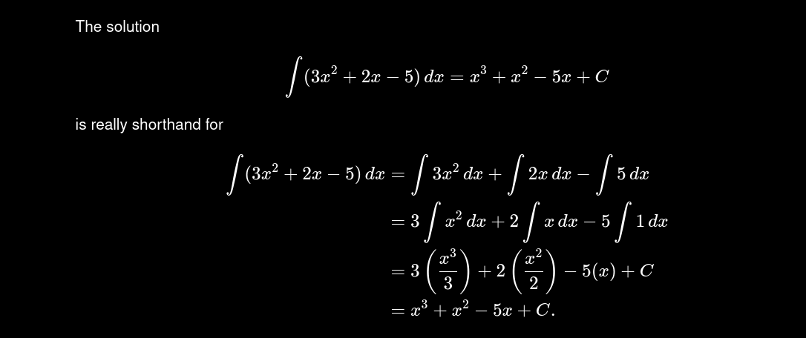

4. The Constant of a Simple Function
∫c dx = c·x + C
Example:
∫7 dx = 7x + C

Definite Integrals and the Fundamental Theorem of Calculus
A definite integral has upper and lower bounds a and b, and gives a single number — the net signed area under the curve between those bounds:
∫(a to b) f(x) dx = F(b) − F(a)
This is the Fundamental Theorem of Calculus: it connects derivatives and integrals by saying that to evaluate a definite integral, find any antiderivative F(x), then subtract its value at the lower bound from its value at the upper bound.

Example
Evaluate ∫(1 to 3) x² dx:
1. Find the antiderivative
F(x) = x³/3
2. Apply the bounds
F(3) − F(1) = (27/3) − (1/3) = 9 − 1/3 = 26/3
✅ Result: The area under y = x² between x = 1 and x = 3 is 26/3 ≈ 8.67 square units.

5. u-Substitution (Reversing the Chain Rule)
When the integrand is a composite function multiplied by the derivative of its inner function, substitute u for the inner function to simplify the integral — this is the integration counterpart of the chain rule.
Example: evaluate ∫2x·(x² + 1)⁴ dx:
1. Choose u
u = x² + 1 ⇒ du = 2x dx
2. Rewrite the integral in terms of u
∫u⁴ du
3. Integrate using the power rule
= u⁵/5 + C
4. Substitute back u = x² + 1
∫2x·(x²+1)⁴ dx = (x²+1)⁵/5 + C

Summary Table
Rule | Formula
Power Rule | ∫xⁿ dx = xⁿ⁺¹/(n+1) + C
Constant Multiple | ∫c·f(x) dx = c∫f(x) dx
Sum / Difference | ∫[f ± g] dx = ∫f dx ± ∫g dx
Constant | ∫c dx = c·x + C
Definite Integral (FTC) | ∫(a to b) f(x) dx = F(b) − F(a)
u-Substitution | Reverses the chain rule

